

Equipment Check-Out (ECS)

INTRODUCTION

In this section you will learn the background information that will prepare you to understand and complete each of the milestones of this case study. This information includes a history of the business, a description of the business’s current facilities, and the descriptions of the problems that triggered the project.

Case Background
GB Manufacturing is a producer of electronic components and testing equipment. The company is located in multiple plants in the New York City area. The corporation has over 10,000 full-time employees.
Approximately 200 employees are employed with the company's Maintenance department, which is responsible for the maintenance of building and grounds. Maintenance has assigned a group of employees to provide maintenance for each building or plant. The employees assigned to each building or plant collectively possess the skills needed to provide proper upkeep. Such employees include carpenters, electricians, painters, welders, plumbers, and the like. The Maintenance department also has a group of employees with special skills to assist with special projects that may arise.

Organization Structure

The following individuals report directly to Bill Venkman, Director of Maintenance. Each of the managers has a group of foremen and supervisors that report directly to him or her, though only the supervisors of the Equipment Depot are listed below.

GB Manufacturing Maintenance Department

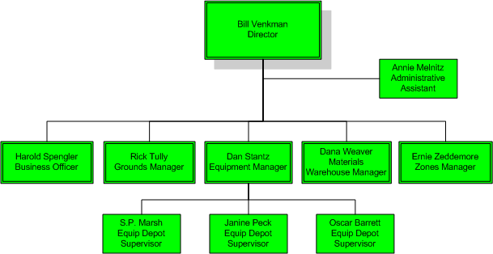

The Problem

In August of 2003 Bill Venkman and his management staff completed a one-week retreat aimed at assessing the maintenance operations. Several initiatives resulted from this retreat. It was determined that the most important initiatives were those that primarily dealt with the equipment depot operation.
The equipment depot's function is to provide the equipment needed by maintenance employees to perform their job duties. Employees are provided with a toolbox containing commonly used, and relatively inexpensive tools such as hammers, screwdrivers, tape measures, and so on. Other tools and pieces of equipment that are needed to complete a job must be checked out through the equipment depot. When the job is completed, the employee must return the checked-out equipment.
Often pieces of equipment become lost, stolen, or damaged and are therefore never checked back in and made available for others. The dollar amount of lost and stolen equipment has reached an alarming total. It has been estimated that more than $50,000 worth of tools are lost or stolen each year. Bill Venkman has decided that something must be done to get the losses under control. Thus, he is giving top priority to the development of a new automated equipment check-out system that that will track the check-in and check out of equipment.
The Materials Warehouse is responsible for obtaining and storing supplies that are needed to complete jobs. For example, the Materials Warehouse makes sure to maintain a supply of screws, nails, plywood, drywall, and other materials. The Materials Warehouse operates in two locations. The main Materials Warehouse is a large building located approximately a mile away from the main campus. For convenience, a smaller Materials Warehouse is located on near the central office and stores a small amount of the most commonly used materials. When workers need materials for a job assignment they are supposed to check both warehouses to see if the goods are available. Unfortunately, the employees are often impatient and will simply check the availability of materials at the smaller, more conveniently located warehouse. If the goods are not available, they routinely choose to simply move on to the next job assignment — rather than checking with the main warehouse. While the main warehouse will provide for the delivery of materials, employees prefer not to have wait for their delivery. To complicate things further, even though the materials may be available at the larger warehouse, employees frequently request that the smaller warehouse order needed materials that are not in stock there. The net result is excessive inventory and inventory carrying costs!
While management is not sure of the total dollar amount that can be attributed to carrying excessive inventory, they are in agreement that it is likely very substantial. Therefore, a new and improved warehousing system is another top priority for the Maintenance Department.

